 COMSATS University Islamabad, Lahore

FALL 2020
□ Sessional-1 □ Sessional-II □ Terminal Examination
Course Title: | Semantic Web (Lab) |  |  |  | Course Code: |  | CSE344 | Credit Hours: | 3(2,1)
Course Instructor/s: | Sana Rizwan |  |  |  | Program Name: |  | BSSE
Semester: | 7th | Batch: | FA17 | Section: | A |  | Date:
Time Allowed: | 1 Hour 15 minutes |  |  |  | Maximum Marks: |  |  | 30
Student’s Name: |  |  |  |  | Reg. No.
Important Instructions / Guidelines:
- Rewriting and cuttings are not allowed. All questions are compulsory.

Question 1: (Marks = 6)
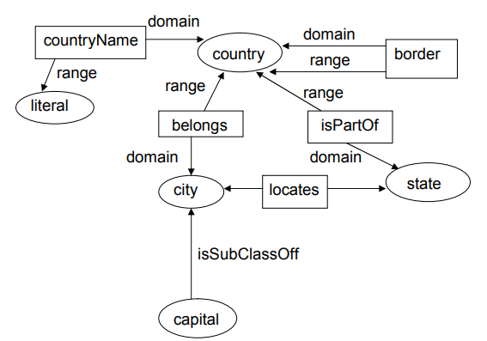
Write RDF/RDFS coding patterns for each statement.

1. State isPartOf Country has domain and range.
2. Country has Border contains domain and range.
3. Capital isSubClassOff city.

Question 2: (Marks = 8)

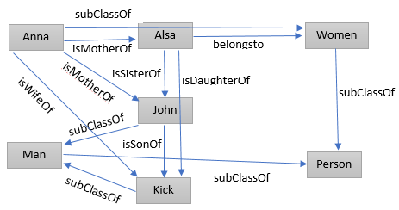
A. Fill the missing Triples with given RDF graph.

1. Anna ________ Alsa
2. Alsa belongsto __________
3. ______ subClassOf Person
4. Anna ________ Kick
5. Anna isMotherOf __________
6. ______ subClassOf Women
7. Alsa __________ John
8. John isSonOf __________
9. ______ isDaughterOf __________
10. Kick ___________ Man
11. Man subClassOf __________
12. _____ belongsto Man

B. Fill missing Relational Form from the given RDF graph:

1. isMotherOf (__________, Alsa)
2. belongsto (Alsa, _________ )
3. __________ (Women, Person)
4. isWifeOf (_______,_______)
5. isMotherOf (________, John)
6. __________ (Anna, Women)
7. __________ (Alsa, John)
8. isSonOf (_______, Kick)
9. isDaughterOf (______, _____)
10. subClassOf (_______, Man)
11. subClassOf (Man, ________)
12. belongsto (________, Man)

Question 3: (Marks = 6)

Define a vocabulary about Person using FOAF with RDF resources in given sequence.
- Declare information using particular resource = http://www.information.org/~abc/contact.rdf#ajmal
- Define email resource = mailto:ajmal.mirza@information.org
- Homepage of resource = http://www.information.org/~abc/
- Declare family_name
- Declare last_name
Question 4: (Marks = 5)

Clothing_brands in shopping abc are Louis Vuitton, Giorgio Armani, Gucci, Prada and Versace

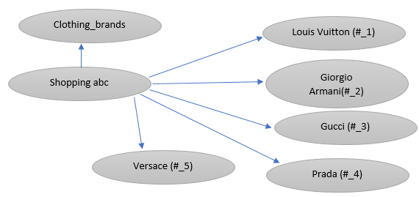

- shopping abc is a Clothing_brand resource from http://Clothingbrand.com/smart
- shopping abc has list of brand names declared in RDF bag
- Title of #_1 should be in sequence as first_name and last_name
- Title of #_3 can have alternative name Guccio Gucci
Question 5: (Marks = 5)

Write a code in XHTML+RDFa having identified features.
- XML declaration
- HTML declaration with concerned PREFIXES
- Head Tag declaration with Title
- Body Tag with DC information and external resource calling from http://cricketpk.org/resource/2020_FALL_IPL to get the data of 2020 FALL IPL

THE END

